APPROVED
by Rīga Stradiņš University
Vice Rector for Science
Decree No 2/2021 as of
09.04.2021
Rīga Stradiņš University
General Rules for Technical Design of Doctoral Thesis to be Submitted to the Promotion Council
Issued in accordance with
Paragraph 3.1, Sub-paragraph 3.1.2 of
Rīga Stradiņš University Regulations
on the Activities of the Promotion Councils
and the Procedure of Promotion
- General provisions
  - Rīga Stradiņš University General Rules for Technical Design of Doctoral Thesis to be Submitted to the Promotion Council (hereinafter – the Rules) shall determine the general technical design requirements for doctoral theses to be submitted to all Promotion Councils of Rīga Stradiņš University (hereinafter – RSU).
  - These Rules shall be binding on the authors of the doctoral theses, who intend to submit their doctoral theses for defence to RSU Promotion Council for obtaining a doctoral degree “Doctor of Science (PhD)”
  - The special rules for the technical design of the doctoral thesis to be submitted to the Promotion Council shall be drawn up by a relevant department(s) upon the instruction of the Vice-Rector for Science in conformity with the traditions established in the relevant sector or sub-sector of science; and they shall be approved by a decree of the Vice-Rector for Science.
  - The doctoral thesis may be:
    - A dissertation.
    - A thematically uniform set of scientific publications (hereinafter – the set of publications).
    - A monograph and at least one internationally reviewed publication.
  - In the event of non-compliance with the general rules and special rules (if any), RSU Promotion Council shall be entitled to postpone the meeting of the Promotion Council and to instruct the author of the doctoral thesis to design the doctoral thesis in conformity with the requirements of the relevant rules.
- General rules for design of doctoral thesis
  - The doctoral thesis and its summaries (in Latvian and English) shall be written in accordance with the style used in scientific writing. The doctoral thesis and its summaries must be drawn up in accordance with the generally accepted format requirements for scientific reports, journals, collections of articles and monographs, paying equal attention to the format of the text, tables, figures, equations and bibliographic sources.
  - In preparing the doctoral thesis for evaluation and publication, the candidate shall observe the text formatting rules in Latvian, published in the Interinstitutional Style Guide (https://op.europa.eu/lv/publication-detail/-/publication/e774ea2a-ef84-4bf6-be92-c9ebebf91c1b )
  - Electronic versions of dissertations or sets of publications (in Latvian or English; full text, including appendices and the graphic part of the work) and its summary (separately in Latvian and English) shall be created as separate PDF and Word files for submission to the Department of Doctoral Studies.
  - The requirements for the dissertation and the set of publications laid down in these Rules shall be observed, as far as possible, in drawing up the monograph.
- Structure of the body text and appendices of the dissertation

  - Length The preferred length of the dissertation shall be up to 150 pages, excluding the bibliography used and appendices.
  - The structure of the dissertation (Appendix No 2)
    - Title page.
    - Annotation in English (including keywords).
    - Annotation in Latvian (including the translation of the title of the work and keywords).
    - Table of contents
    - Explanation of the abbreviations used in the work.
    - Introduction.
    - Subsequent sections of the work.
    - Conclusions.
    - Proposals (if any).
    - Publications and reports on the topic of the dissertation and the set of publications shall be designed in accordance with [in the order indicated] the recommendations of RSU “Methodological Guidelines for Citing References and Compiling Bibliography” (https://www.rsu.lv/sites/default/files/imce/Dokumenti/Biblioteka/izmantoto_avotu_un_literaturas_saraksta_noformesanas_metodiskie_noradijumi_2017.pdf), as well as in accordance with the publication requirements:
      - Scientific publications included in international databases (Web of Science, SCOPUS, ERIH PLUS );
      - Scientific articles published in peer-reviewed publications in Latvia;
      - Scientific articles published in peer-reviewed publications abroad;
      - Patents obtained from the European Patent Office (EPO), United States Patent and Trademark Office (USPTO), Japan Patent Office (JPO) and Eurasian Patent Organisation (EAPO);
      - Patents registered with the Patent Office of Latvia;
      - A presentation at an international scientific conference with an oral report or an abstract not included in the databases referred to in paragraph 3.2.10.1;
      - A presentation at a local scientific conference with an oral report or an abstract not included in the databases referred to in paragraph 3.2.10.1.
    - Bibliography.
    - Acknowledgements (if any).
    - Appendices (if any).

- Structure of the body text and appendices of the set of publications

  - Length The length of the set of publications depends on the length of publications attached to appendices.
  - The structure of the set of publications (Appendix No 3)
    - Analogous to the structure of the dissertation from paragraphs 3.2.1 to 3.2.6.
    - Materials.
    - Methods.
    - Statistical analysis.
    - Results.
    - Discussion.
    - Conclusions.
    - Proposals (if any).
    - Bibliography.
    - Acknowledgements (if any).
    - Appendices:
      - First publication;
      - Second publication;
      - Third publication;
      - Fourth publication.

- Technical design of the dissertation and the set of publications
  - Format: A4 (210 mm × 297 mm).
  - Page layout (the so-called page “mirror”):
    - Margins: 2.0 cm at the top and bottom (including the centred page number in the lower area (11 pt, Regular)); 2.5 cm on the right side and 2.5 cm on the left side.
    - Page numbering shall be automatic. There shall be no page numbering on the Title page, but it shall be included in the total number of pages.
  - Style of typeface: black Times New Roman for all the work.
  - Font size and line spacing:
    - The body text: 12 pt, Regular style, line spacing – 1.5 lines; text alignment: Justify, First Line Indent: 1.25 cm.
    - The heading of the Table of contents (Table of Contents): 14 pt, Bold. The font size of the text in the Table of Contents: 12 pt (as for the body text), line spacing (interval): Single. The blocks of chapters shall be separated from each other by a space of 6 pt.
    - 1st level headings of the hierarchical structure (chapter headings): 14 pt, Bold, centred; line spacing (interval): Single.
    - 2nd, 3rd and lower level headings of the hierarchical structure (sub-chapter headings): 12 pt, Bold; aligned to the left edge without indentation; line spacing (interval): Single.
    - Letters, numbers and symbols in equations: 12 pt.
    - The number of a table and figure: 11 pt, Regular.
    - The heading of a table and the caption for a figure: 11 pt, Bold, with a Single line spacing. A space of 6 pt must be left between the heading and the table itself and between the figure and the figure caption.
    - The text and numbers in tables and figures (charts, diagrams, images): 11 pt Regular, with a Single line spacing.
    - The footnote text and explanatory text below tables and figure captions: 10 pt Regular, with a Single line spacing.
    - The text for literature sources and other bibliography lists: 11 pt with a Single line spacing, separating one entry from the other with a 6 pt space.
  - Title page. Information to be included on the Title page (Appendix No 1):
    - In Latvian:
      - Rīgas Stradiņa universitātes logo (LV horizontālā versija);
      - [Darba autora Vārds Uzvārds];
      - Atvērtais pētnieka un līdzautora identifikators ORCID [Nr.];
      - [Darba nosaukums];
      - Promocijas darbs zinātniskā doktora grāda “zinātnes doktors (Ph.D.)”
      - Nozare (saskaņā ar MK noteik. Nr. 49 “Noteikumi par Latvijas zinātnes nozarēm un apakšnozarēm”, 23.01.2018.) – [nosaukums nominatīvā];
      - Apakšnozare (saskaņā ar MK noteik. Nr. 49 “Noteikumi par Latvijas zinātnes nozarēm un apakšnozarēm”, 23.01.2018.) – [nosaukums nominatīvā];
      - Promocijas darba vadītājs(-a; -i) – [Zin. grāds] [akadēmiskais amats] [Vārds Uzvārds], [Institūcija];
      - Ja ir: Zinātniskais(-ā) konsultants(-e; -i) – [Zin. grāds] [akadēmiskais amats] [Vārds Uzvārds], [Institūcija];
      - [Informācija par līdzdalību ES vai citos projektos, projekta finansiālu atbalstu, ES vai attiecīgā projekta logo (kārtība – vispirms logo, tad informatīvais apraksts)];
      - Rīga, [gads].
    - In English:
      - Rīga Stradiņš University logo (ENG horizontal version);
      - [Name Surname of the author of the work];
      - Open Researcher and Contributor iD ORCID [No];
      - [Title of the Work];
      - Doctoral Thesis for obtaining a doctoral degree “Doctor of Science (PhD)”;
      - Sector – [....];
      - Sub-sector – [....];
      - Supervisor(-s) of the Doctoral Thesis: [Academic degree] [academic position] [Name Surname], [Institution];
      - If applicable: Scientific Advisor(-s) - [Academic degree] [academic position] [Name Surname], [Institution];
      - [Information on participation in the EU or other projects, financial support for the project, the logo of the EU or the relevant project (order: first the logo, then informative description)];
      - Riga, [year];
  - Table of Contents (Appendix No 2 for the dissertation; Appendix No 3 for the set of publications):
    - The Table of contents shall contain the headings of the parts of the work (chapters and sub-chapters) and the page numbers on which they are located.
    - To insert a Table of contents, it is recommended to use paragraph styles for headings in the main section (at least for those that will be included in the contents) and the Word content creation tool (Table of Contents), because then it is technically easier to change the number of chapters, to insert pages and change page numbers in the process of restructuring the doctoral thesis.
  - Chapters and Sub-chapters (Appendix No 4):
    - Full stops shall not be used at the end of headings, and the headings do not need to be underlined.
    - It is advisable to divide the text into chapters and sub-chapters up to a maximum of the third level of hierarchical structure, following their numbering sequence, using Arabic numerals (1, 1.1, 1.1.1). The fourth level headings shall not be numbered.
    - Chapter headings “Annotation”, “Table of Contents”, “Abbreviations”, “Introduction”, “Conclusions and Proposals”, “Publications and Reports on the Topic of the Doctoral Thesis”, “Bibliography”, “Acknowledgements”, “Appendices” do not have to be numbered.
    - Headings and sub-headings of chapters do not have to be written on separate pages, but together with the text (with the exception of “Appendices”).
    - Chapters and their headings (1st level of hierarchical structure) shall be written on a new page.
    - Headings for sub-chapters and further subdivisions (e.g. 1.2 and 1.2.1) should not be started on a new page if at least 3 lines of the text can be entered below the heading of the sub-chapter at the bottom of the page.
    - If it is necessary to create further hierarchical structure headings beyond level 3, they should also be highlighted in comparison with the letters of the body text, for example, in Bold or Italic.
    - There should be an additional line space as in the body text between headings/sub-headings and the text and between the text and the heading of the following sub-chapter.
  - Explanation of the abbreviations used in the work, if necessary, should be placed after the Table of contents on a new separate page.
  - All words and compounds in the text should be used in full form with corresponding declension endings to clearly show the relationship between the words. If an abbreviation is used, it must comply with the generally accepted spelling rules of the official language.
  - Text highlights. When creating highlights in the text, it is not recommended to use more than 3 different ways of highlighting the text (letters of different sizes, letters in Bold, Italic) within one piece of work. Do not use underscores and spacing to highlight the text.
  - The letters of the Greek alphabet shall be written in light (Regular) type (without bold and italics).
  - Characters denoting arithmetic functions (such as “=”, “<”, “>”, “+”, “-”, “±”, “≤”, “≥”, “≠”, etc.) shall be separated from both sides by a space (one blank character), which facilitates the perception of information. It is recommended that these characters shall be combined with a numerical value of the quantity using the non-breaking space to avoid dividing the numerical value and the corresponding character into two lines.
  - Tables, figures and equations:
    - Shall be placed in the text after the first reference to them.
    - If the information contained in the table or figure, as well as the equation written in the text, has been borrowed, this should be indicated in the reference to the relevant data source. The reference should be in the heading of the table or directly below it, next to the figure heading or in the reference/explanation of the relevant equation.
    - Table headings and texts, figure captions, footnotes and explanatory notes shall be written with a Single line spacing.
  - Tables (Appendix No 5):
    - The tables shall be numbered in Arabic numerals in ascending order within each chapter using double numbering (the chapter number and the numerical order of the table, for example, Table 6.1).
    - When inserting a table, one blank line space should be left above and below the table "block" (table number + heading + table + explanatory notes) to the body text or the heading of the following sub-chapter or other "block" of the table or figure.
    - The table heading should be in bold, horizontally centred. There shall be no full stop at the end of the heading.
    - The table number (for example, Table 1.1) shall be placed on the right side of the page above the table heading.
    - The heading should be short, specific and clearly understandable, stating the topic and content of the table.
    - The width of the table must not exceed the vertical side limits of the body text (i.e. the “mirror” of the page); if it is narrower, the table shall be centred horizontally at the width of the “mirror”.
    - Tables for which the number of rows and columns is less than three shall not be created. The thickness of the lines forming the network of tables shall be ½ pt; the background colour shall not be used.
    - The column headings of the table shall be centred and in bold; but the row headings (usually in the first column) shall be aligned to the left.
    - In the columns of the table, the first words shall be capitalized, in the sub-columns - in lower case.
    - Diagonal lines shall not be allowed in the table.
    - All cells in the table must be filled in.
    - When including figures in the table in the description of the results, some general basic principles should be followed:
      - The accuracy of the numerical information within the table must be the same; a comma (10,25) is used as a decimal separator in Latvian, a point in English (10.25);
      - Decimal numbers shall be given to two decimal places after a comma (or a decimal point), except for the probability p, which can be given to 3 decimal places after a comma (or a point).
    - The table may also continue on the following pages without a heading but with the reference “… continuation of the table” or “…end of the table”. The column headings of the table must be repeated on each page.
  - Explanatory notes below the table should be formatted as follows: space from the table: 6 pt, aligned to the left edge:
    - First, the information that applies to the entire table as a whole.
    - Then the information relating to the individual parts of the table.
    - Finally, an explanation of the level of statistical significance.
  - Figure (Appendix No 5). All illustrations – drawings, charts, diagrams, graphs, scans, photos, etc., are figures (a sample layout in Appendix No 5).
    - Figures shall be numbered in Arabic numerals in ascending order within the chapter, using double numbering (chapter number and the numerical order of the figure, for example, Figure 6.1).
    - When inserting a figure, one blank line space should be left above and below the figure "block" (figure + figure caption + explanatory notes) to the body text or the heading of the following sub-chapter or other "block" of the figure or table.
    - The width and height of the figure (together with the figure caption and explanatory notes below it) must not exceed the boundaries of the body text (i.e. the “mirror” of the page); if the figure is narrower than a “mirror”, it shall be centred horizontally within the width of the body text; the figure caption (and the notes below it) shall be centred at the width of the figure.
    - Each figure must be given an appropriate heading - the figure caption, which is written below the figure in one line with the number of the figure (for example, Figure 2.3 Heart valve).
    - The caption below the figure shall be centred horizontally – recommended within the width of the figure.
    - Technical execution of figures: scanned photos, drawings and graphs shall be carried out with specialized computer programs; it is advisable to use the same thickness of lines as in diagram/graph network lines – ½ pt.
    - It is advised to prepare graphs to be included in the doctoral thesis in black and white. Background colour and the enclosing frame thereof shall not be used. Legends should be avoided on the figures and should be replaced by abbreviations, numbers and symbols, which should be decoded in the explanatory notes below the figure caption. Value axes must be named.
  - Equations (Appendix No 4):
    - Equations shall be centred horizontally in the middle of the width of the body text.
    - If there is more than one equation, they shall be numbered. Numbering can be common throughout the work or separately by chapter (e.g. 3.1), if there are many equations. Sequential numbers shall be written in parentheses opposite the equation on the right side of the page.
    - Decoding of the symbols used in the equations shall be written below the equation (each in its own line).
    - One blank line space equivalent to one row of body text shall be left above and below the equation or equation block (equation on a separate line + explanations of symbols).
    - The equation creation program Equation Editor or other programs shall be used to create equations.
    - The units of measurement of the quantities included in the equations shall be written after their names or numerical values.
  - Units of measurement, their derivatives and designations shall be used and recorded in accordance with the Cabinet Regulations No 1186 of 29 October 2013 “Regulations of the Units of Measurement” (https://m.likumi.lv/doc.php?id=261495). The abbreviated designations of measurement units (e.g. mg) shall be used after the numerical values of the quantity, in the column headings of the tables and in the explanations to the equations. It is recommended to connect them to the numerical value of a quantity using a non-breaking space to avoid splitting the numerical value and the unit of measurement into two lines. A full stop shall not be used after the abbreviated designations of measurement units.
  - References in the text and bibliography (Appendix No 6), as well as Publications and Reports on the Topic of the Doctoral Thesis shall be drawn up in accordance with RSU recommendations "Methodological Guidelines for Citing References and Compiling Bibliography”
(https://www.rsu.lv/sites/default/files/imce/Dokumenti/Biblioteka/izmantoto_avotu_un_literaturas_saraksta_noformesanas_metodiskie_noradijumi_2017.pdf ), as well as in accordance with the specific nature of the relevant sector and the hierarchy of the sources.
  - Appendices to the doctoral thesis, created as a dissertation, may be attached, if they are evaluated in the main body of the work.
    - Appendices shall be separated from the rest of the work by a separate page bearing the title Appendices (this page shall not be numbered, but shall be included in total numbering; subsequent pages shall be numbered).
    - The materials in the appendix should be numbered in the upper-right corner in Arabic numerals (e.g. Appendix No 1) - font size 11 pt, light (Regular). The title of each appendix should be placed below the number, centred within the width of the page text "mirror" – font size 11 pt, in Bold.
    - The title of the appendix shall be placed in such a way that the title is fully legible even after folding the page (if the page of the appendix is larger than an A4 page).
    - Appendices must contain the source references, unless the appendix is created by the author himself/herself.
  - Appendices to the doctoral thesis, created as a set of publications; each publication shall be a separate appendix.

- Technical design of the summary of the dissertation and the set of publications
  - Length The recommended length – up to 50 pages.
  - The structure of the work:
    - Title page.
    - Table of contents
    - Explanation of the abbreviations used in the work.
    - Introduction.
    - Subsequent sections of the work.
    - Conclusions.
    - Proposals (if any).
    - Publications and reports on the topic of the doctoral thesis [in the order specified]:
      - Scientific publications included in international databases (Web of Science, SCOPUS, ERIH PLUS );
      - Scientific articles published in peer-reviewed publications in Latvia;
      - Scientific articles published in peer-reviewed publications abroad;
      - Patents obtained from the European Patent Office (EPO), United States Patent and Trademark Office (USPTO), Japan Patent Office (JPO) and Eurasian Patent Organisation (EAPO);
      - Patents registered with the Patent Office of Latvia;
      - A presentation at an international scientific conference with an oral report or an abstract not included in the databases referred to in paragraph 5.2.8.1;
      - A presentation at a local scientific conference with an oral report or an abstract not included in the databases referred to in paragraph 5.2.8.1.
    - Bibliography.
    - Acknowledgements.
    - Appendices (if any).
  - Technical design. The principles of the design of the summary are analogous to the design of the dissertation and the set of publications (Appendix No 7), subject to the following exceptions (see paragraphs 6.4 – 6.8).
  - Format: A5 (148 mm × 210 mm).
  - Page layout:
    - The pages should have Mirror margins. Margins: 1.5 cm at the top and 2.0 cm at the bottom (including the centred page number in the lower area (10 pt, Regular)); 2.0 cm on the inner edge and 1.5 cm on the outer edge.
    - Page numbering shall be automatic. The Title page and the accompanying data page of the summary shall not be numbered, but shall be included in the total number of pages.
  - Font size and line spacing:
    - Body text: 10 pt (Regular), First Line Indent: 1 cm (10 mm).
    - Font size of the content text: 10 pt (as for the main body of the text), line spacing (interval): Single.
    - 1st level headings of the hierarchical structure (chapter headings): 12 pt, (Bold).
    - 2nd and 3rd level headings of the hierarchical structure (sub-chapter headings): 11 pt, (Bold).
    - Numbers of tables and figures: 10 pt.
    - Headings of tables and captions for images: 10 pt, (Bold).
    - Text in tables, figures, footnotes and explanations below figures and tables: 9 pt, (Regular)
    - Sources of literature and bibliography lists: 9 pt with a Single line spacing, but with 6 pt spacing between the entries.
  - Information to be included on the title page of the Summary (Appendix No 8)
    - In Latvian:
      - Rīgas Stradiņa universitātes logo (LV horizontālā versija);
      - [Darba autora Vārds Uzvārds];
      - Atvērtais pētnieka un līdzautora identifikators ORCID [Nr.];
      - [Darba nosaukums];
      - Promocijas darba kopsavilkums zinātniskā doktora grāda “zinātnes doktors (Ph.D.)” iegūšanai;
      - Nozare (saskaņā ar MK noteik. Nr. 49 “Noteikumi par Latvijas zinātnes nozarēm un apakšnozarēm”, 23.01.2018.) – [nosaukums nominatīvā];
      - Apakšnozare (saskaņā ar MK noteik. Nr. 49 “Noteikumi par Latvijas zinātnes nozarēm un apakšnozarēm”, 23.01.2018.) – [nosaukums nominatīvā];
      - Rīga, [gads].
    - In English:
      - Rīga Stradiņš University logo (ENG horizontal version);
      - [Name Surname of the Author of Doctoral Tesis];
      - Open Researcher and Contributor iD ORCID [No];
      - [Title of the Work (all content words should be capitalised)];
      - Summary of the Doctoral Thesis for obtaining a doctoral degree “Doctor of Science (Ph.D.)”;
      - Sector – [....];
      - Sub-sector – [....];
      - Riga, [year];
  - Information to be included on the data page of the Summary (Appendix No 9)
    - In Latvian:
      - Promocijas darbs izstrādāts [Institūcijā];
      - Promocijas darba vadītājs(-a; -i): [Zin. grāds] [akadēmiskais amats] [Vārds Uzvārds], [Institūcija];
      - If applicable: Zinātniskais(-ā) konsultants(-e; -i): [Zin. grāds] [akadēmiskais amats] [Vārds Uzvārds], [Institūcija];
      - Oficiālie recenzenti: [Zin. grāds] [akadēmiskais amats] [Vārds Uzvārds], [Institūcija];
      - Promocijas darbs tiks aizstāvēts [Nozare] promocijas padomes atklātā sēdē [gads un datums] [plkst.] [vieta];
      - Ar promocijas darbu var iepazīties RSU bibliotēkā un RSU tīmekļa vietnē: https://www.rsu.lv/promocijas-darbi;
      - [Informācija par līdzdalību ES vai citos projektos, projekta finansiālu atbalstu, ES vai attiecīgā projekta logo (kārtība – vispirms logo, tad informatīvais apraksts)];
      - Promocijas padomes sekretārs: [Zin. grāds] [akadēmiskais amats] [Vārds Uzvārds].
    - In English:
      - The Doctoral Thesis was developed at [Institution]:
      - Supervisor(-s) of the Doctoral Thesis: [Academic degree] [academic position] [Name Surname], [Institution];
      - If applicable: Scientific Advisor(-s): [Academic degree] [academic position] [Name Surname], [Institution];
      - Official Reviewers: [Academic degree] [academic position] [Name Surname], [Institution];
      - Defence of the Doctoral Thesis will take place at the public session of the Promotion Council of [Sector] in [place] on [date and year] at [time];
      - The Doctoral Thesis is available in RSU library and on RSU website: https://www.rsu.lv/doctoral theses;
      - [Information on participation in the EU or other projects, financial support for the project, the logo of the EU or the relevant project (order: first the logo, then informative description)];
      - Secretary of the Promotion Council: [academic degree] [academic position] [Name Surname].
- Final provisions
  - If the requirements of these Rules do not comply with the requirements of external laws and regulations or the requirements of internal laws and regulations of higher power, the requirements of external laws and regulations or the requirements of internal laws and regulations of higher power shall be applied.
- Appendix No 1 – Title Page of the Doctoral Thesis (sample).
- Appendix No 2 – Table of Contents of the Doctoral Thesis (Dissertation) (sample).
- Appendix No 3 – Table of Contents of the Doctoral Thesis (Set of Publications) (sample).
- Appendix No 4 – Text, Headings and Equations of the Doctoral Thesis (sample).
- Appendix No 5 – Table and Figure of the Doctoral Thesis (sample).
- Appendix No 6 – Bibliography of the Doctoral Thesis (sample).
- Appendix No 7 – Text and Headings of the Set of Publications (sample).
- Appendix No 8 – Title Page of the Summary of the Doctoral Thesis (sample).
- Appendix No 9 – Data Page of the Summary of the Doctoral Thesis (sample).
Acting Vice-Rector for Science J.Vīķe

L.Stepanova, 67409290
Laura.Stepanova@rsu.lv

THIS DOCUMENT IS ELECTRONICALLY SIGNED WITH A SECURE ELECTRONIC SIGNATURE AND CONTAINS A TIME STAMP

Appendix No 1
to Rīga Stradiņš University General Rules for Technical Design of Doctoral Thesis to be Submitted to the Promotion Council

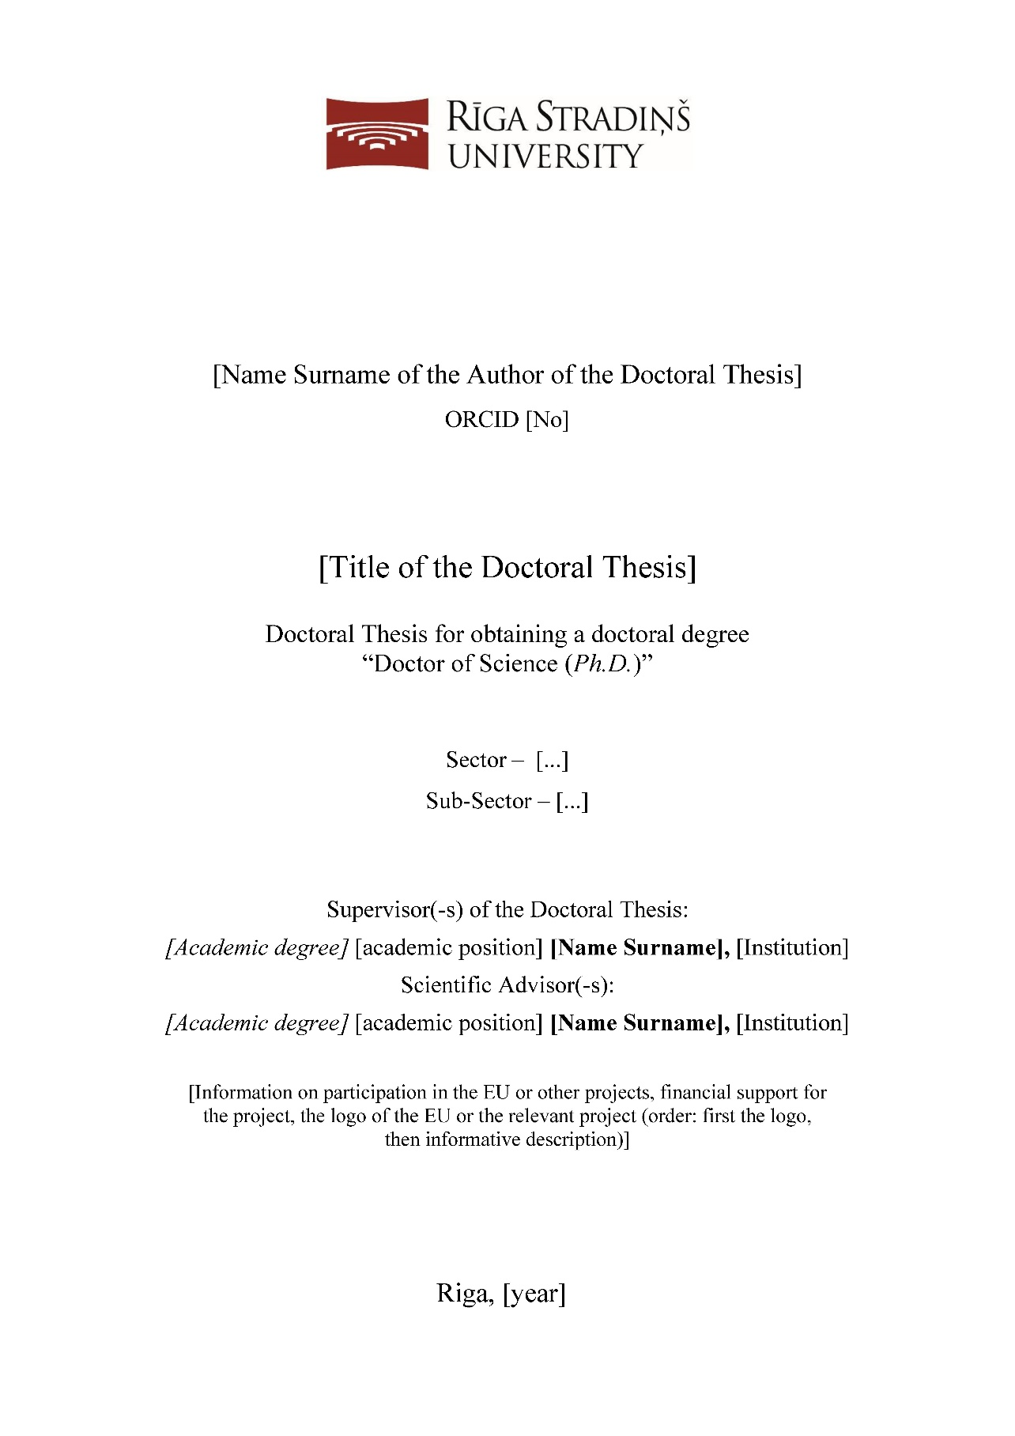
Appendix No 2
to Rīga Stradiņš University General Rules for Technical Design of Doctoral Thesis to be Submitted to the Promotion Council

Table of Contents of the Doctoral Thesis (Dissertation) (sample).

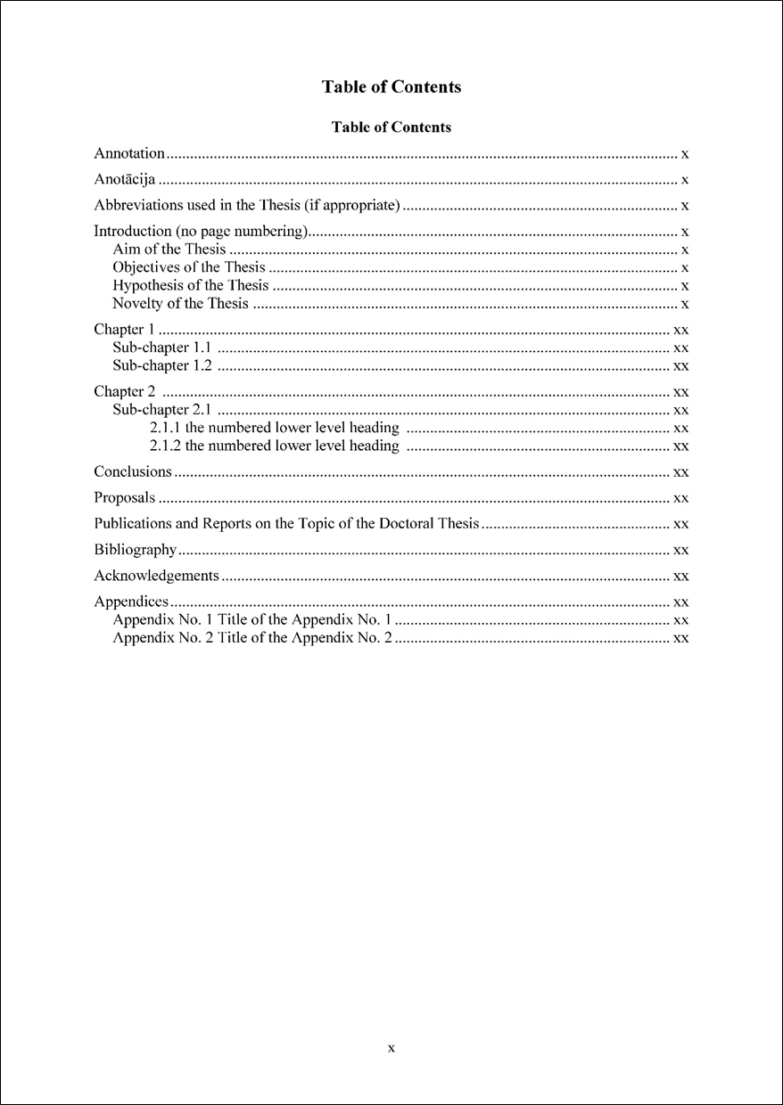

Appendix No 3
to Rīga Stradiņš University General Rules for Technical Design of Doctoral Thesis to be Submitted to the Promotion Council

Table of Contents of the Doctoral Thesis (Set of Publications) (sample).

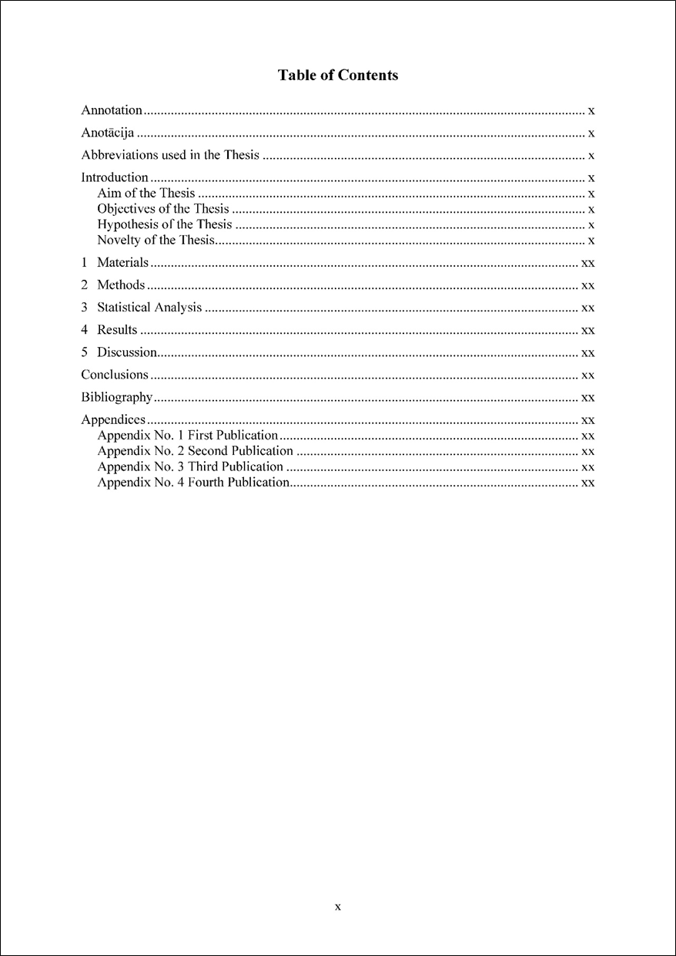
Appendix No 4
to Rīga Stradiņš University General Rules for Technical Design of Doctoral Thesis to be Submitted to the Promotion Council

Text, Headings and Equations of the Doctoral Thesis (sample).

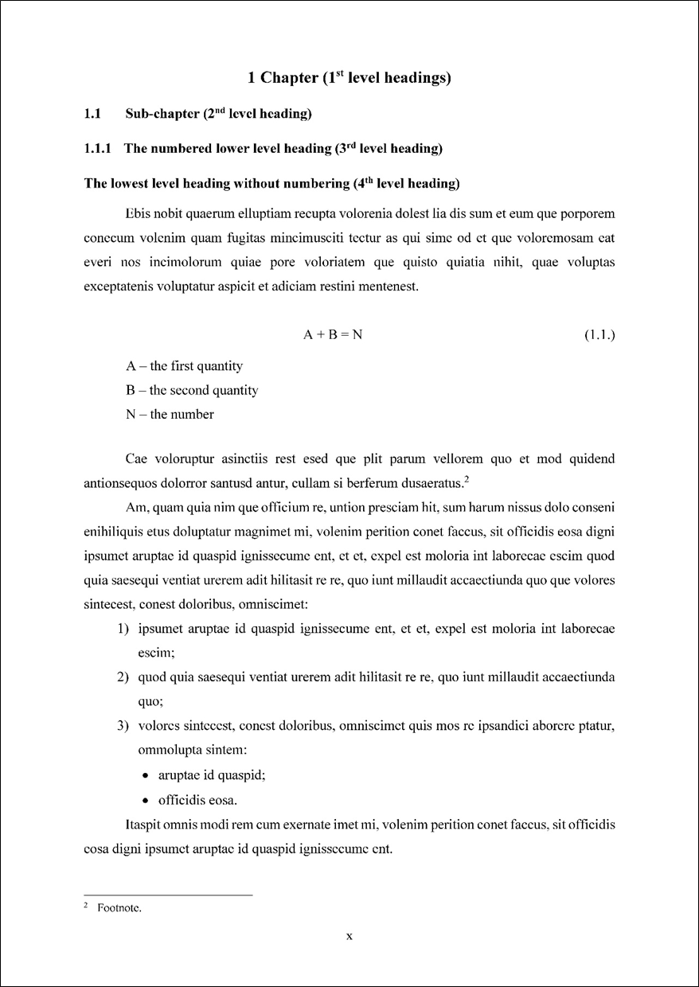

Appendix No 5
to Rīga Stradiņš University General Rules for Technical Design of Doctoral Thesis to be Submitted to the Promotion Council

Table and Figure of the Doctoral Thesis (sample).

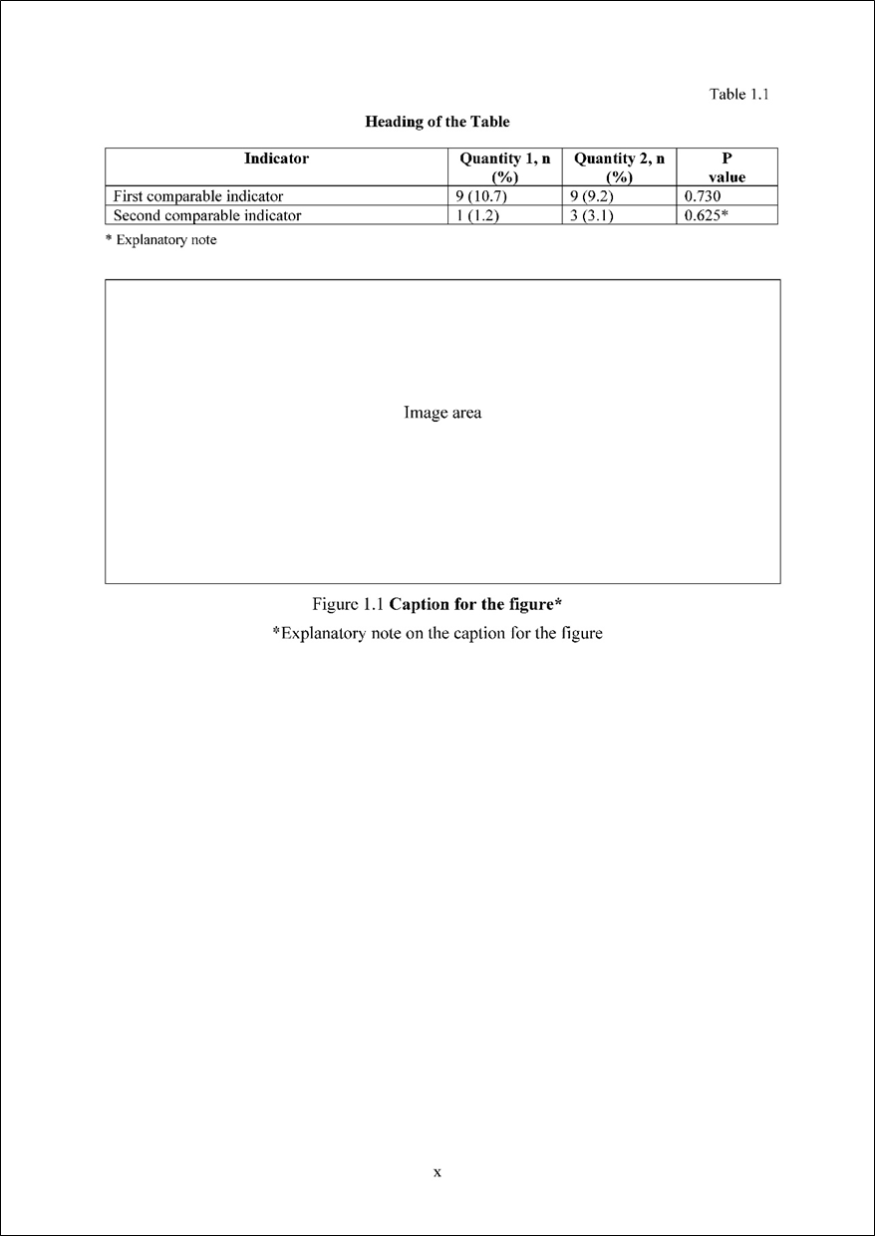

Appendix No 6
to Rīga Stradiņš University General Rules for Technical Design of Doctoral Thesis to be Submitted to the Promotion Council

Bibliography of the Doctoral Thesis (sample).

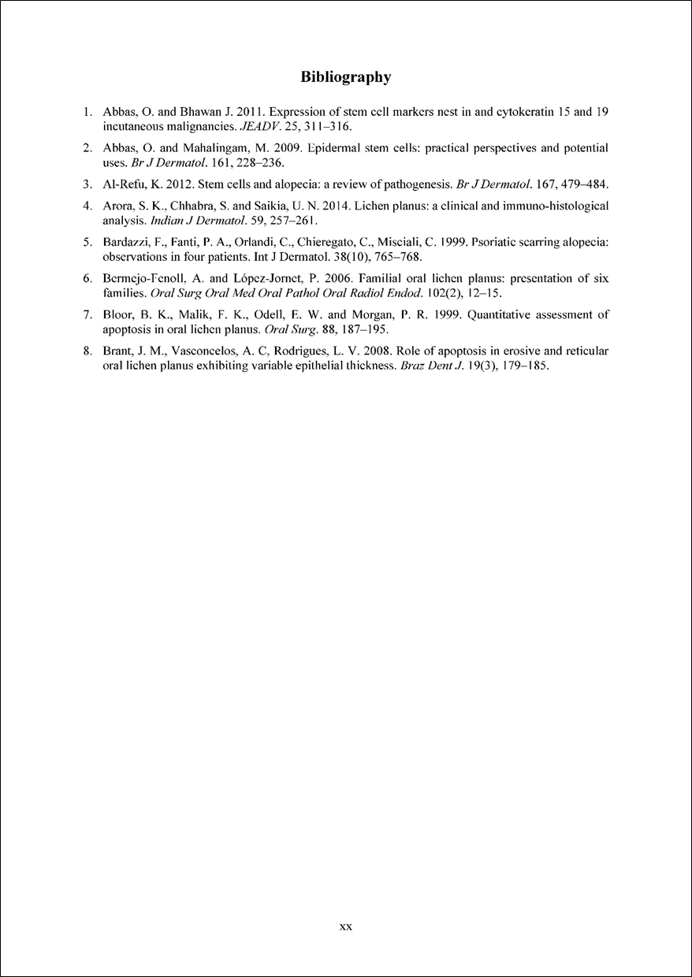
Appendix No 7
to Rīga Stradiņš University General Rules for Technical Design of Doctoral Thesis to be Submitted to the Promotion Council

Text and Headings of the Set of Publications (sample).

Appendix No 8
to Rīga Stradiņš University General Rules for Technical Design of Doctoral Thesis to be Submitted to the Promotion Council

Title Page of the Summary of the Doctoral Thesis (sample).

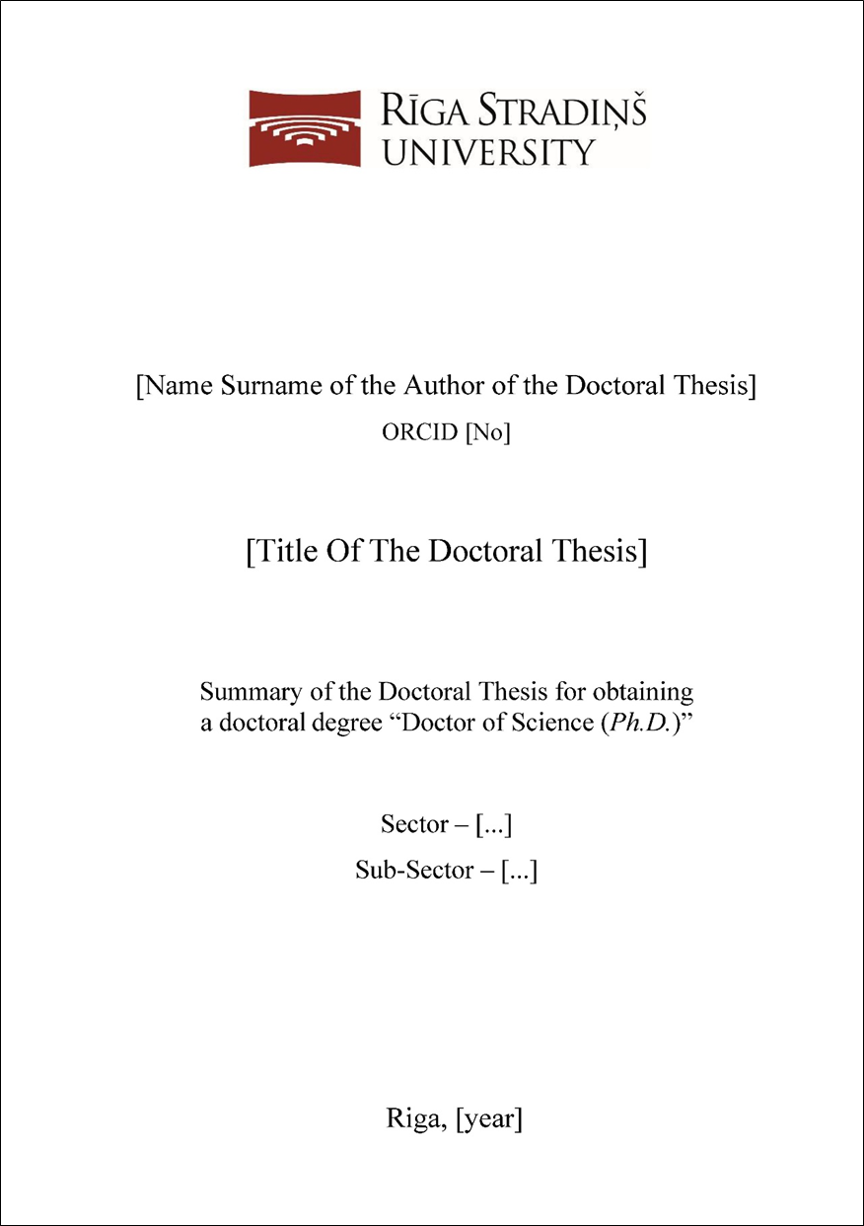
Appendix No 9
to Rīga Stradiņš University General Rules for Technical Design of Doctoral Thesis to be Submitted to the Promotion Council

Data Page of the Summary of the Doctoral Thesis (sample).

