WORKSHOP GUIDANCE NOTES

BUILDING A SIMPLE MARKOV COST UTILITY MODEL IN MICROSOFT EXCEL
In this exercise we will build a very simple state transition Markov model with three defined health states. This will output a cost utility estimate for a new intervention relative to a baseline comparator. The diagram below gives the basic structure of the model.
Asymptomatic
Progression
Death

Such a model could be used, for example, to model a new drug treatment for cancer. Here we use a cohort of 1000 people modelled over a time horizon of 20 years with a cycle length of 1 year.

DEVELOPMENT STEPS:
1: Create initial spreadsheet with three worksheets named: Parameters, Model, Graphs
2: In the Parameters worksheet create the input tables (as below):
3. Enter the parameter values within the input tables for both the comparator arm and the intervention arm of the model as shown.
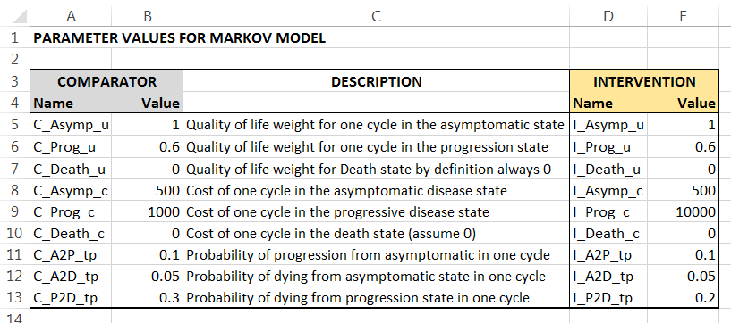
4. Assign names to the value cells (use naming box top left – copy name from the adjacent cell and remember to press enter for each). You need to do this for all 18 values in the table. The example below shows the name entered for cell B5.
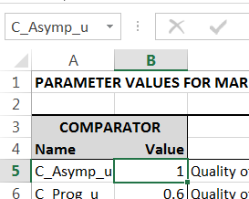
5. In the Model worksheet create the following tables
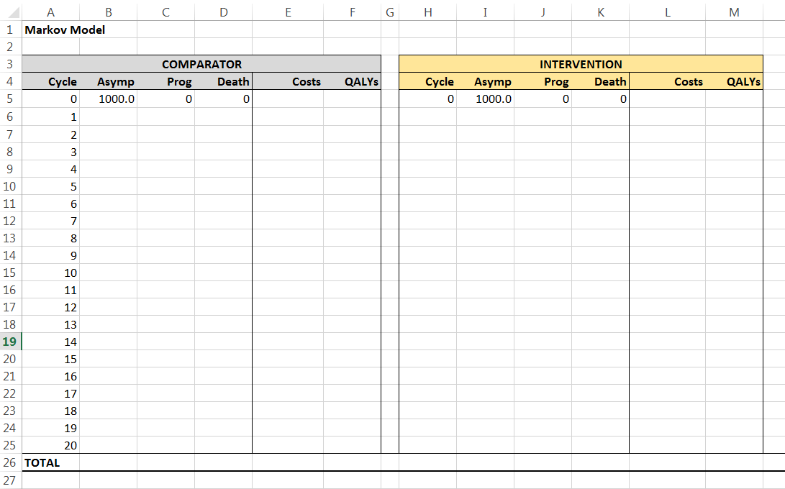
6. Now for the Comparator Arm enter the formulae necessary to calculate the state populations for Cycle 1 of the model (cells B6, C6, D6). Take your time to carefully work out the required formulae for each of these three cells. To help you the example below shows the formula required for cell C6.
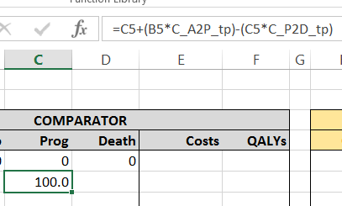
7. Copy the formulae from cells B6:D6 down the table to row 25 (i.e cycle 20). You may want to check that the Sum across the three columns B-D for each cycle row now equals 1000 (i.e. the population remains at a 1000 throughout the model).
8. Enter the formula in cell E6 needed to calculate the Cost total for the cycle 1. This will be the sum of each state population multiplied by the cycle cost per patient in that state.
9. Enter the formula in cell F6 needed to calculate the QALY total for cycle 1. This will be the sum of each state population multiplied by the cycle quality of life weight of that state.
10. Copy the formulae from cells E6:F6 down the table to row 25.
11. Add the totals for the costs and QALY columns in cells E26 and F26. You may then want to format the Costs column using Currency option and adjust the decimal point formatting for other columns. Your table should now look as below
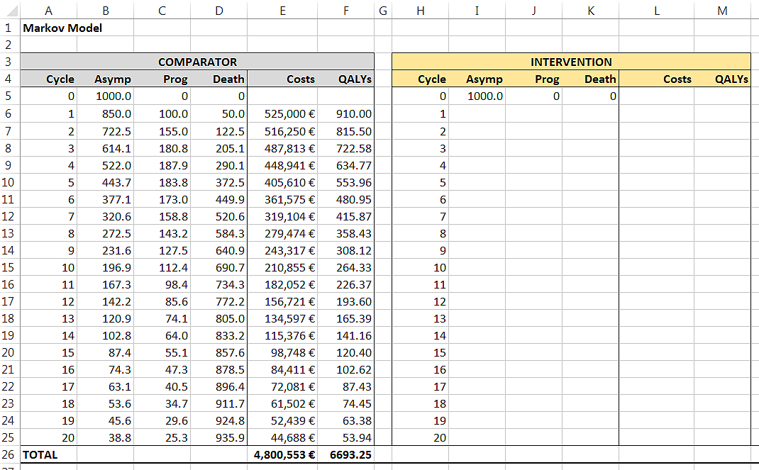
12. Save your model at this point.
13. Now copy the contents of the Comparator Arm (Range A6:F26) and paste across to the Intervention Arm of the model (Range H6:M26).
14. Select the Intervention Arm contents (Range H6:M26) and perform a find and replace function – Replacing C_ with I_ (make sure you include the underscore) this will then convert this arm of the model to representing the Intervention parameter values.
15. Now create the Model Output table in the Model worksheet as shown below copying across the cell references from the Totals in the model arms (Row 26). The Incremental Cost Effectiveness Ratio is simply the differences in Costs Total (Intervention minus Comparator) divided by the differences in QALY Total.
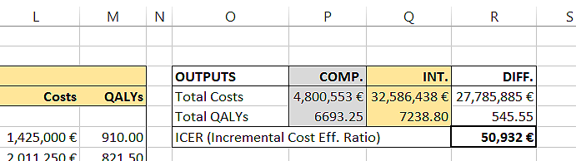
16. It would useful now to copy the Outputs table across to the Parameters worksheet. To do this select and copy the whole table, select the Parameters worksheet, and then use Paste Special first using ‘paste format’ and then ‘paste links’.
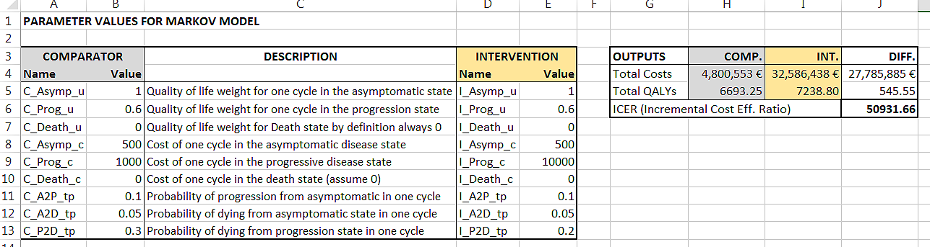

17. You may now want to create some simple graphs showing the population declines in the Asymptomatic and Progression state for each of the arms. These can be place in the Graphs worksheet if you wish as below. The respective areas under the lines for each arm are proportional to the populations surviving in the Asymptomatic and Progression states. The increased area between the two lines effectively represents the health gain in terms of added survival in the progression state which is delivered by the intervention treatment relative to the comparator.
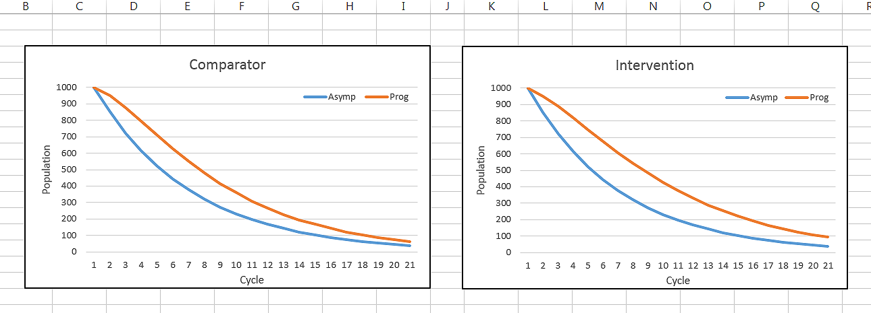

18. Having created the simple model you can now do some basis sensitivity analysis looking at how changes to the input parameters affect the model outputs. Using your model see if you can find the intervention cost which would bring the ICER below 30,000 euros. What difference does changing the drug effectiveness parameter (I_P2D_tp) have on the outputs? What about changes to the utility parameters?

MODEL SIMPLIFICATIONS
Please note - there are many simplifications in this basic model example outlined in these guidance notes. Below are some examples of further elements that might generally be expected in a full cost effectiveness model. Many source references for these can be found on the internet:
- Discounting for QALYs and Costs – used to reflect the dis-benefit of delays in accrual of costs and benefits (typically values of around 3.5% annually are used)
- Half cycle correction – to account for inter-cycle average in population rather than initial value to improve accuracy (important when large cycle times are used)
- Time dependent transition probabilities – to account for changes in transition probabilities during the time horizon of the model (e.g. probability of death becomes more likely as modelled population ages)
- Transition costs – one-off costs associated with events (transitions from one state to another – e.g. on death).
- Additional health states – to add greater detail to the model structure (e.g. different levels of severity for the modelled disease or the occurrence of adverse events/side effects).
- Probabilistic Sensitivity Analysis – used to account for the uncertainty associated with input parameters when values are sampled from probabilistic density functions rather than having assign fixed values.

