International conference

Improving Patient Safety and Quality in Latvia

Rīga Stradiņš University,
Dzirciema street 16, Riga, Latvia
June 7, 2018

Agenda

Aim of the conference is to strengthen common awareness and thus, to promote culture of patient safety in health care settings both among health workers and policy makers and support policy decisions to strengthen patient safety in Latvia, by capitalizing on what has been achieved so far at the national level and sharing successful international experience and practice.
Target audience: health professionals of various specialties, health policy makers, NGOs and other stakeholders.
Organizers: National Health Service in cooperation with the Ministry of Health, Centre for Disease Prevention and Control and World Health Organization Country Office in Latvia.
Conference participants will receive 8 continues education points.

Time | Speaker and presentation title
8:45- 9:30 | Registration
Opening of the conference
9:30 - 9:40 | Anda Čakša, Minister of Health of the Republic of Latvia

1st session: Patient safety culture in limited recourse setting
Aim of the session is to give a WHO’s perspective of patient safety at global and regional level; what are the main challenges and how to better promote culture of patient safety in health care settings.

Chair of the session: Basia Kutryba, Dr., Chief Advisor at the National Center for Quality Assessment in Healthcare (NCQA), Krakow, Poland
9:40 - 10:10 | Basia Kutryba, Dr., Chief Advisor at the National Center for Quality Assessment in Healthcare (NCQA), Krakow, Poland  - WHO patient safety solutions. A leverage for change of health care organization’s culture  Maryanne D’Arpino, RN, BScN, MScN, CHE, Senior Director, Safety Improvement and Capability Building with the Canadian Patient Safety Institute, Canada  - Global perspectives on patient safety and WHO initiatives
10:10 - 10:30 | Simon Faldbæk Peitersen, M.Sc. in Public Health, Chief consultant, Danish Society for Patient Safety  - Patient safety – a journey that involves culture and learning – and how legislation can support the development
10:30 - 10:50 | Walter Kuchenbecker, MBChB, FCOG, PhD., Dr., Gynaecologist, Isala Clinics, Zwolle, The Netherlands  - Fostering a culture of patient safety and quality improvement, a clinician’s perspective
10:50 - 11:05 | Evija Palčeja, Dr., Patient Safety Manager, Children`s Clinical University Hospital; Senior Expert at the Patient Safety and Quality of Healthcare Improvement Unit, Centre for Disease Prevention and Control of Latvia; Lecturer and researcher at the University of Latvia, Latvia  - Patient safety climate in Latvia
11:05 - 11:20 | Basia Kutryba, Dr., Chief Advisor at the National Center for Quality Assessment in Healthcare (NCQA), Krakow, Poland  - Summary of the session, discussion
11:20 - 11:55 | Coffee break

2nd session: Safety standards for invasive procedures: role of the team and human factor
Aim of the session is to introduce participants with safety standards for invasive procedures, underlying the role of teamwork and human factor; share obstacles and opportunities from the safety standard implementation process in health care facilities.
Chair of the session: Viesturs Boka, Dr., MD, Prof., Professor of the Department of Surgery at Faculty of Medicine, University of Latvia, Latvia.
11:55 - 12:05 | Viesturs Boka, Dr., MD, Prof., Professor of the Department of Surgery at Faculty of Medicine, University of Latvia, Latvia  - Introduction of the topic
12:05 - 12:25 | Guttorm Brattebø, Prof., MD, Consultant Anaesthetist, Department of Anaesthesia & Intensive Care, Haukeland University Hospital, Bergen, Norway; Professor of Traumatology, Dept. of Clinical Medicine, University of Bergen, Haukeland University Hospital, Bergen, Norway  - Safety standards for invasive procedures and IV medications: How to improve safety by focusing on the team function?
12:25 - 12:40 | Biruta Mamaja, Dr., MD, Asoc.prof., the Cheaf Anesthetist at Riga East Clinical University Hospital Clinical Centre "Gaiļezers"; Lecturer of Anesthesiology and Reanimatology Department at Rīga Stradiņš University, Latvia  Haralds Plaudis, Dr., MD, Asoc.prof., Head Surgical Specialist at Riga East Clinical University Hospital; lecturer at Rīga Stradiņš University, Latvia  - Surgical checklist implementation at Riga East Clinical University Hospital Clinical Centre "Gaiļezers"; issues and solutions
12:40 - 13:00 | Viesturs Boka, Dr., MD, Prof., Professor of the Department of Surgery at Faculty of Medicine, University of Latvia, Latvia  - Summary of the session, discussion
13:00 - 13:55 | Lunch break

3rd session: Multidisciplinary approach to sepsis prevention, early diagnostics and treatment
Aim of the session is to introduce participants with different roles, approaches and actions from stakeholders for sepsis prevention, early diagnosis and treatment.
Chair of the session: Uga Dumpis MD., PhD., Professor Infectious Diseases, University of Latvia; Head of Department of Infectious Diseases and Infection Control in Pauls Stradins Clinical University Hospital, Latvia
13:55- 14:05 | Uga Dumpis MD, PhD, Professor Infectious Diseases, University of Latvia; Head of Department of Infectious Diseases and Infection Control in Pauls Stradins Clinical University Hospital, Latvia  - Introduction of the topic
14:05 - 14:25 | Einar Hovlid, MD, PhD, Project manager, Norwegian Board of Health Supervision; Associate professor University of Bergen, Norway  - Emergency department screening of patients with risk of sepsis and time to treatment
14:25 -14:50 | Christopher Horvat, Dr., MD, MHA, Assistant Professor of Pediatric Critical Care and Director of Health Informatics for Clinical Effectiveness at Children’s Hospital of Pittsburgh of UPMC, United States of America  A Modern Approach to the Fundamentals of Sepsis Recognition, Management and Performance Improvement
14:50 - 15:10 | Uga Dumpis MD, PhD, Professor Infectious Diseases, University of Latvia; Head of Department of Infectious Diseases and Infection Control in Pauls Stradins Clinical University Hospital, Latvia  - Summary of the session, discussion
15:10 - 15:45 | Coffee break

4th session: Best practices in patient safety and quality of care in hospital setting
Aim of the session is to share the best practices, creative and successful ideas in hospital setting regarding patient safety and quality of care.
Chair of the session: Reinis Balmaks, Dr., MD, Assistant Professor, Department of Clinical Skills and Medical Technology at Rīga Stradiņš University; Consultant, Pediatric Intensive Care Unit, Children's Clinical University Hospital, Latvia
15:45 – 15:55 | Reinis Balmaks, Dr., MD, Assistant Professor, Department of Clinical Skills and Medical Technology at Rīga Stradiņš University; Consultant, Pediatric Intensive Care Unit, Children's Clinical University Hospital, Latvia  Introduction of the topic
15:55 - 16:10 | Christopher Horvat, Dr., MD, MHA, Assistant Professor of Pediatric Critical Care and Director of Health Informatics for Clinical Effectiveness at Children’s Hospital of Pittsburgh of UPMC, United States of America  - Leveraging Electronic Health Record Data to Optimize Patient Safety and Quality of Care
16:10 – 16:25 | Simon Faldbæk Peitersen, M.Sc. in Public Health, Chief consultant, Danish Society for Patient Safety  - Results from EU Network on Patient Safety and Quality of Care (pasq.eu) and best practices around patient safety and quality of care
16:25 – 16:45 | Reinis Balmaks, Dr., MD, Assistant Professor, Department of Clinical Skills and Medical Technology Rīga Stradiņš University; Consultant, Pediatric Intensive Care Unit, Children's Clinical University Hospital, Latvia  - Summary of the session, discussion
Conclusion of the conference
16:45 – 17:05 | Anda Čakša, Minister of Health of the Republic of Latvia;  Basia Kutryba, Dr., Chief Advisor at the National Center for Quality Assessment in Healthcare (NCQA), Krakow, Poland  Maryanne D’Arpino, RN, BScN, MScN, CHE, Senior Director, Safety Improvement and Capability Building with the Canadian Patient Safety Institute, Canada  - Conclusion and summary of the conference

Information about speakers
1st session: Patient safety culture in limited recourse setting
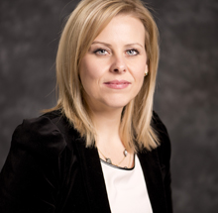
Maryanne D’Arpino, RN, BScN, MScN, CHE, Senior Director, Safety Improvement and Capability Building with the Canadian Patient Safety Institute
Maryanne holds a master’s degree in Science and Nursing (Leadership and Education stream) from York University, a Bachelor of Science and Nursing from Ryerson University, and has worked in progressive leadership roles on a provincial and national scale for many years. Maryanne has held various roles in the Long-Term Care and Community Health sector in Ontario, including clinician, clinical nurse educator, case manager with CCAC Community Care Access Centre, and Director of Nursing. In her current role as Senior Director, Safety Improvement and Capability Building with the Canadian Patient Safety Institute (CPSI), Maryanne leads pan-Canadian initiatives in health provider education (capability building and knowledge translation), quality improvement and research in patient safety. Through the National Integrated Patient Safety Action Plan, and specifically, the home care safety action plan, she provides leadership and fosters strong alliances with a multi-partner, pan-Canadian stakeholder group.
Contact information:
Email: mdarpino@cpsi-icsp.ca
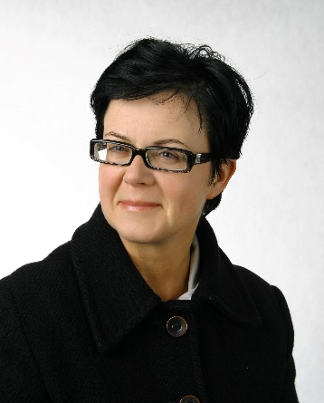
Basia Kutryba, Dr., Chief Advisor at the National Center for Quality Assessment in Healthcare (NCQA), Krakow, Poland

Basia currently is a Chief Advisor at the National Center for Quality Assessment in Healthcare (NCQA) in Krakow, Poland. She was a President of the EU Expert Group on Patient Safety and Quality of Care from year 2007 till 2017. She is fellow of the European Society for Quality in Healthcare (ESQH) and Vice president of the Polish Society for Quality Promotion in Healthcare in Poland.
Contact information:
Email: kutryba@cmj.org.pl
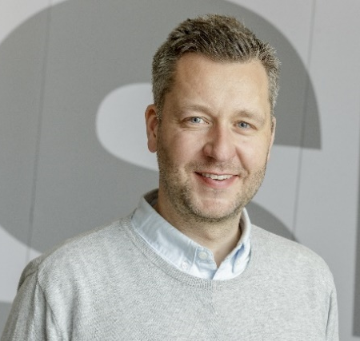
Simon Faldbæk Peitersen, M.Sc. in Public Health, Chief consultant, Danish Society for Patient Safety
Simon holds a Master of Science in Public Health from University of Copenhagen, Denmark, from where he graduated in 2009. Following graduation, he joined the Danish Health Authority for five years before starting at the Danish Society for Patient Safety in March 2014. At the Danish Health Authority Simon worked with national health care/hospital planning, as well as international issues like the WHO EB and World Health Assembly and the EU Health Security Committee. At the Danish Society for Patient Safety Simon has been program director for the Danish Patient Safety Program in Mental Health and work package leader for the EU Network for Patient Safety and Quality of Care (PaSQ Joint Action).
Contact information
Email: Simon.peitersen@patientsikkerhed.dk

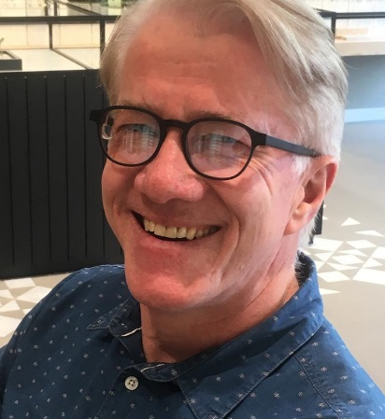
Walter Kuchenbecker, Dr., MBChB, FCOG, PhD, Gynaecologist, Isala Clinics, Zwolle, The Netherlands
After graduating from medical school at the University of Pretoria, South Africa, he worked as a medical officer and general practitioner in a low resource rural setting in Namibia, industrialised setting in South Africa and a rural setting in Canada. After qualifying as gynaecologist at the University of Pretoria, he followed a two-year fellowship in reproductive medicine and surgery at the University of Pretoria and the Catholic University of Leuven in Belgium. Since 2001 he is working as a gynaecologist and specialist in reproductive medicine and surgery in the Netherlands. Since 2006, he is actively involved in quality management at the Isala clinics, a non-academic teaching hospital.
Contact information
Email: w.k.h.kuchenbecker@isala.nl
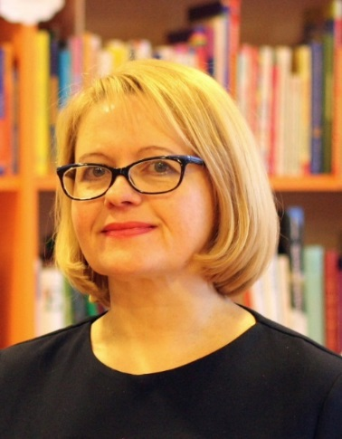
Evija Palčeja, Dr., Patient Safety Manager, Children`s Clinical University Hospital; Senior Expert at the Patient Safety and Quality of Healthcare Improvement Unit, Centre for Disease Prevention and Control of Latvia; Lecturer and researcher at the University of Latvia
Evija Palčeja is a pediatrician andsince 2013 also the Head of the Patient safety system at the Children’s Clinical University Hospital and the European Hospital and Healthcare Federation (HOPE) exchange programme coordinator in Latvia. Inspired by her education in quality management (mg.sc.TQM), and gained practical experience at the hospital and on the European level, Evija Palčeja started to give lectures in 2009 and in cooperation with the Rīga Stradiņš University carried out first training seminars on patient safety and clinical risk management. She also gives lectures on patient safety at the University of Latvia and the School of Business Administration Turība. Evija Palčeja has been a part of the Education and Training Sub-group of the European Commission Patient Safety & Quality of Care Working Group, working on recommendation on patent safety. Her practical experience at the Children’s Hospital where she developed patient safety culture and built the reporting learning system from the ground up currently is used for national-level activities within the Quality and Patient Safety Concept.
Contact information
Email: evija.palceja@bkus.lv; evija.palceja@spkc.gov.lv
2nd session: Safety standards for invasive procedures: role of the team and human factor
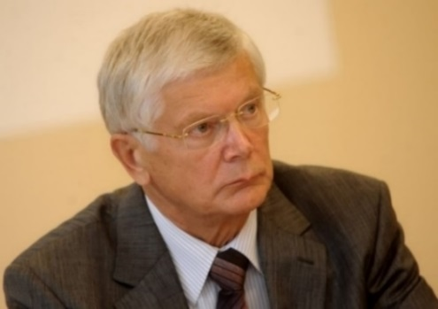
Viesturs Boka, Dr., MD, Prof., Professor of the Department of Surgery of Faculty of Medicine, University of Latvia, Latvia.
Professor Viesturs Boka currently works as a professor at the Surgical Department of the Faculty of Medicine, University of Latvia. He has PhD in medicine and master’s degree in business management. He is the author of 120 scientific publications. From 2005 to 2015, Viesturs Boka served as the Head of the Board of the Riga East Clinical University Hospital; up until 2017, he was a board member. He has served as a member of the 6th Parliament and a member of the Riga Council. He has taken an active role in the Latvian Medical Association. Currently he serves as a member of the Scientific Council of the Faculty of Medicine, University of Latvia and the Chairman of the Scientific Council of the Clinical and Preventive Medicine Institute, University of Latvia. He is also an expert at the Latvian Academy of Sciences in the field of medicine. In 2008, he was awarded the Order of the Three Stars (Officer rank). In 2013, he was awarded Grade I honorary mark “Tempus Hominis” by the Latvian Medical Association.
Contact information
Email: viesturs.boka@lu.lv
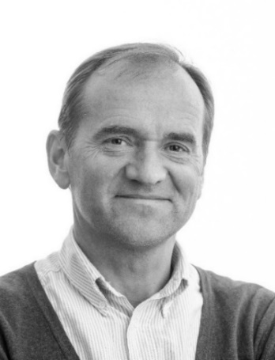
Guttorm Brattebø, Prof., MD, Consultant Anaesthetist, Dept. of Anaesthesia & Intensive Care, Haukeland University Hospital, Bergen, Norway; Professor of Traumatology, Dept. of Clinical Medicine, University of Bergen, Haukeland University Hospital, Bergen, Norway
Dr. Guttorm Brattebø is a professor of traumatology and consultant anaesthetist. He has previously been the managing and medical director of Bergen EMS for 17 years. His research has been in quality improvement (ICU sedation practices and trauma team training). His main interest is patient safety (team function and non-technical skills, and how safety is created, rather than being threatened). He is founder and board chairman of the BEST Foundation (Better & Systematic Teamtraining), which for more than 20 years has been initiated team training for acute care teams in most Norwegian hospitals, and primary health care teams in more than 50 municipalities nationwide. He is member of the European Board of Anaesthesiology in the UEMS and has been appointed a Fellow of the European Resuscitation Council (FERC).
Contact information
Email: guttorm.brattebo@kokom.no
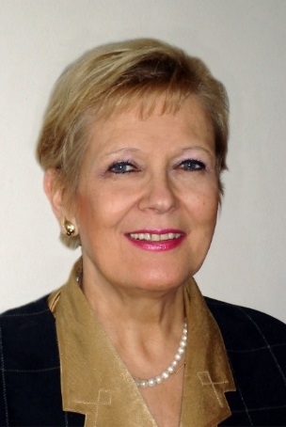
Biruta Mamaja, Dr., MD, Asoc.prof., Head physician at the Clinic of Anesthesiology at Hospital “Gaiļezers” of the Riga East Clinical University Hospital; Lecturer at the Anesthesiology and Reanimatology Department of the Rīga Stradiņš University, Latvia.
Biruta Mamaja has been an Associated professor at the Anesthesiology and Reanimatology Department of the Rīga Stradiņš University since 2005. She gained PhD degree in medicine in 1992. Head physician at the Clinic of Anesthesiology at Hospital “Gaiļezers” of the Riga East Clinical University Hospital since 2013; person-in-charge for resident training in the field of anesthesiology- reanimatology at the Riga East Clinical University Hospital since 2011. Author of book “Anesthesiology in Pediatrics” and co-author of three books “Clinical Anesthesiology and Intensive Therapy”; author of 190 scientific publications. She is also an expert at the Latvian Academy of Sciences in the field of medicine. From 1996 to 2016, she was the Latvian representative at the European Society for Pediatric Anesthesiology. Active member of the European Society of Anesthesiology.
Contact information
Email: Biruta.Mamaja@aslimnica.lv
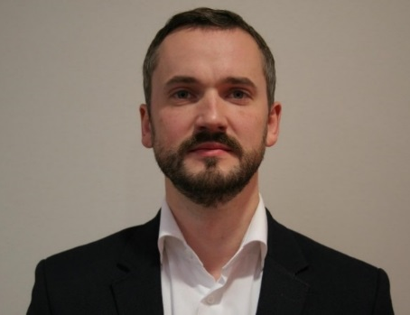
Haralds Plaudis, Assoc.Prof., MD, PhD, Head Specialist in Surgery, Riga East Clinical University Hospital. Rīga Stradiņš University
Assoc.prof. Haralds Plaudis (MD, PhD) currently is Head Specialist in Surgery in Riga East Clinical Hospital that is the largest hospital in Latvia. He is also Associated professor in Surgery at Rīga Stradiņš University and Head Specialist in Surgery in Latvian Ministry of Health. In 2014 he graduated Stockholm School of Economics in Riga and in 2017 INSEAD finishing "Innovating Health for Tomorrow" program. Currently he is actively working as a hepato-pancreato-billiary and upper gastrointestinal tract surgeon.
Contact information
Email: Haralds.plaudis@aslimnica.lv
3rd session: Multidisciplinary approach to sepsis prevention, early diagnostics and treatment
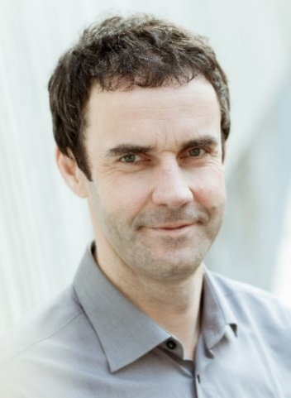
Uga Dumpis MD, PhD, Professor of Infectious Diseases, University of Latvia; Head of Department of Infectious Diseases and Infection Control in Pauls Stradins Clinical University Hospital
Prof. Uga Dumpis (MD, PhD, DTM) is currently professor in Infectious Diseases, Universityof Latvia, Department of Internal Medicine. He is also head of Department of Infectious Diseases and Infection Control, Pauls Stradins Clinical University Hospital. He is also Chief Specialist of Infectious Diseases, Ministry of Health Latvia, Core member of European Medicines Agency Committee for Human Medicinal Products (CHMP) Scientific Advisory Group (SAG), ESGAP (European Study Group of Antimicrobial Stewardship) member. In hospital he is responsible for antimicrobial stewardship and infection control programs. His research interests have been antimicrobial resistance, treatment of severe infections in ICU, quality interventions and outbreak investigation.
Contact information
Email: Uga.Dumpis@stradini.lv
Einar Hovlid, MD, PhD, Project manager, Norwegian Board of Health Supervision; Associate professor University of Bergen
Einar Hovlid oversees the Norwegian Board of Health Supervision´s research program into effects of supervision and is also an associate professor at the University of Bergen. He is a medical doctor and has a PhD in quality improvement in health care. Over the last decade his main research interest has been how care delivery to patients can be improved. The latest project has been looking at how external inspections affect care delivery to patients with sepsis in emergency departments in Norwegian hospitals.
Contact information
Email: fmsfeho@fylkesmannen.no
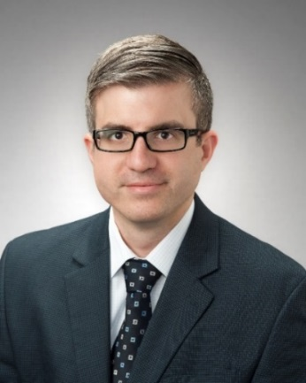
Christopher Horvat, Dr., MD, MHA, Assistant Professor of Pediatric Critical Care and Director of Health Informatics for Clinical Effectiveness at Children’s Hospital of Pittsburgh of UPMC
Dr. Horvat is a practicing pediatric intensivist at the Children’s Hospital of Pittsburgh of UPMC, where he also completed his fellowship training in pediatric critical care, as well as a National Institute of Health-funded post-doctoral research fellowship, additional clinical training in neurocritcal care and a master’s Degree in Health Administration from the University of Pittsburgh School of Public Health. His research leverages existing components of the health system, including electronic record data and remnant biologic samples, to track clinical performance, shed new light on disease and improve patient outcomes.
Contact information
Email: Christopher.horvat@chp.edu

4th session: Best practices in patient safety and quality of care in hospital setting
Reinis Balmaks, Dr., MD, Assistant Professor, Department of Clinical Skills and Medical Technology Rīga Stradiņš University; Consultant, Pediatric Intensive Care Unit, Children's Clinical University Hospital
Dr. Reinis Balmaks works in Paediatric Intensive Care Unit at Children’s Clinical University Hospital and teaches medical students at Rīga Stradiņš University. Dr. Balmaks received medical degree at Rīga Stradiņš University in 2007. After medical studies he did residency in pediatrics at Children’s Hospital in Riga and then two fellowships in pediatric critical care medicine – at St. Louis Children’s Hospital, US, and Great Ormond Street Hospital, UK. In 2014 Dr. Balmaks earned Phd at Rīga Stradiņš University. Currently, his research interests are pediatric intensive care epidemiology and outcomes and technology enhanced medical education. Dr. Balmaks studies more effective methods to improve educational experience and uses simulations as environment for clinical studies.
Contact information
Email: reinis.balmaks@rsu.lv

