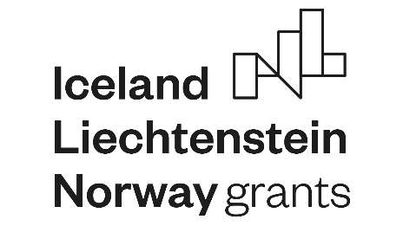

Accademic/scientific and administrative staff
Grant application and confirmation to conditions
Staff mobility between Riga Stradins University and University of Iceland to establish scientific collaboration in the nutrition field
EEA-GRANT-218
of the Programme “Research and Education” of the EEA and Norway Financial Mechanism 2014-2021 under the Activity “Scholarships”

This form should be kept at the home institution with a copy to the coordinating institution. Note, that the grant will not be paid out before this form has been completed and signed.

Please, don’t fill your application in handwriting. Only typed documents are accepted.

Name, surname _______________
Personal identity number __________________
Date of birth _____________ Sex ____________ Citizenship _______________

Home institution_________________

Host institution ____________
Exchange period from _____________ to _______________
International Bank Account number (IBAN + BIC) ___________________

1. I agree to use the scholarship exclusively to cover costs for travel, board and lodging and possible language courses, all directly connected to my mobility in the Iceland, Liechtenstein, Norway or Latvia.
2. If I cancel or interrupt my mobility, I agree to pay back the scholarship or part of it.
3. I agree to take out the necessary insurances.
4. I will submit a feedback document after my mobility period, and a copy will be sent to the contact person in my university and to the project coordinator.

I confirm that all information provided is correct and I agree to terms and conditions of the programme.
Place and date: Signature:

________________ _______________________________

