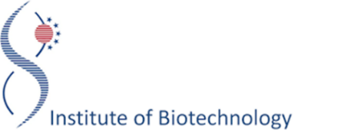

TRAINING COURSE
“Principles of immunohistochemistry for studying the presence of parvovirus B19 specific antigens in brain tissue”
December 2-4, 2019
Vilnius, Lithuania

AGENDA

Trainee: Anda Vilmane
Supervisor: Martynas Simanavičius
Venue: Institute of Biotechnology Vilnius University, Department of Immunology and Cell Biology, Saulėtekio al. 7, LT-10257 Vilnius, Lithuania
Funding: Cooporation project “Studying of human parvovirus B19, bocavirus and parvovirus 4 involvement in inflammatory neurological diseases using interdisciplinary approach” (project number: LV-LT-TW/2016/13// No. 6.2.-26/2016/0073)

Day 1, December 2nd, 2019
9:00 – 17:00 – Briefing on principles of immunohistochemistry, preparation of brain tissue sections for staining (deparaffinization, rehydration of tissue section, antigen retrieval); beginning of antibody staining of brain tissue sections (blocking of unspecificities using goat serum, overnight incubation with primary antibody specific to B19 antigen)
Day 2, December 3rd, 2019
9:00 – 17:00 – Staining of the tissue sections using secondary antibody specific to murine immunoglobulin, development of a signal where immune complexes with B19 specific antigen are formed, counterstaining of nuclei in the tissue sections using chemical dye, dehydration of the tissue sections, preservation of the stained tissue section.
Day 3, December 4th, 2019
9:00 – 17:00 – Briefing on using an EVOS FL Auto Imaging System, microscopic observation and imaging of the stained brain tissue sections, evaluation of the results.

