Dear Colleagues, Applicants for the Scientist Grant.
Below is a brief guide on how to submit your Scientist Grant applications in the NZDIS system.
If you already have a username and password for the portal, follow these steps:
- Access the System by visiting the portal: https://sciencelatvia.gov.lv/
- Click on the “Log In” button located at the top corner of the page

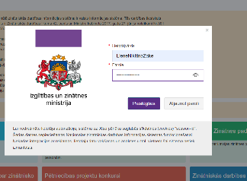
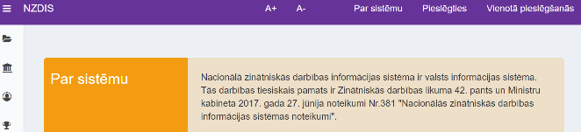

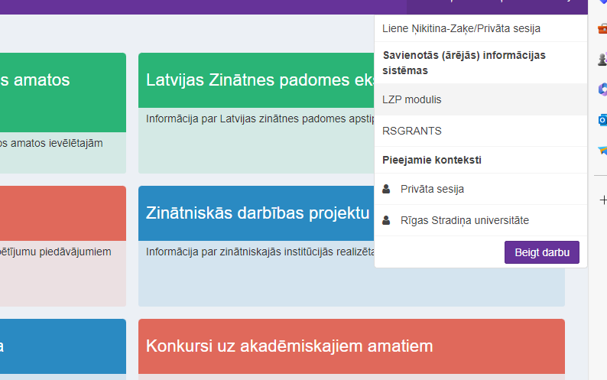
- After logging in, click on your name and navigate to the NZDIS LZP module

- Within the LZP module, locate the “+ Add New Project” button under the LZP emblem at the top corner of the page. Select the option for “Fundamental and Applied Research Projects (FLPP)
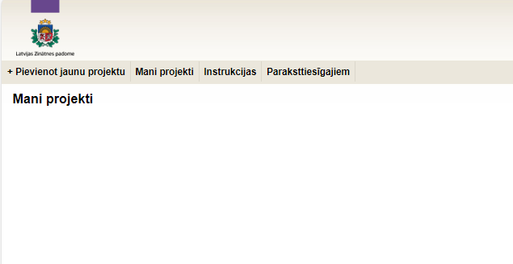
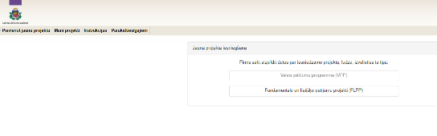

- From the dropdown list, select “Riga Stradiņš University Researcher Grant Competition (RSU-ZG-2024/1)” and proceed to fill in the required information in the system.
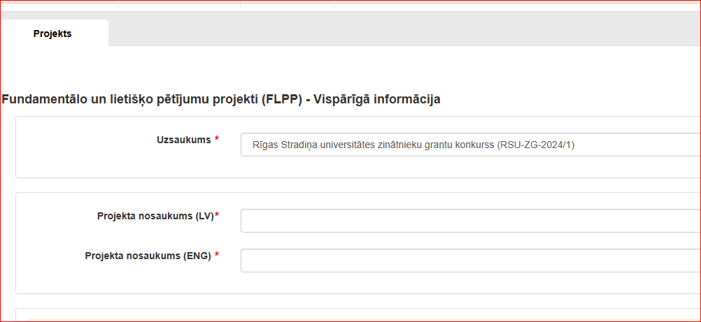
- Indicate the grant priorities under the "Type of Funding" section:
- RSU LSPA ZG: First priority;
- RSU-ZG: Second priority.

