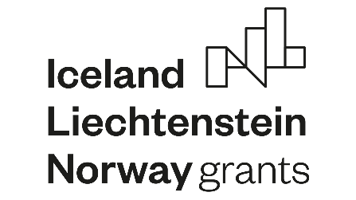

Application form & Learning agreement for student exchange
Promotion of healthy ageing, welfare and social security EEA-GRANT-205

To be completed by the student (Fill in by computer, please).
Please submit the completed application to your contact person in home institution.
 | Student’s name, surname
 | Personal identity number
 | Address
 | E-mail address
 | Age
 | Home institution
 | Host institution
 | Academic year
 | Exchange period |  | from dd/mm/yyyy/ to dd/mm/yyyy
 | Field of study
 | Number of completed study years prior exchange
 | Type of exchange | Study exchange □ |  |  | Practical placement □
Student’s signature
........................................................................................... Date: ............................................................
SENDING INSTITUTION
We confirm that the proposed programme of study / learning agreement is approved.
Departmental coordinator  .............................................................................  Signature: |  |  |  | Date: ...................................................................
RECEIVING INSTITUTION
We confirm that this proposed learning agreement is approved.
Departmental coordinator  ..............................................................................  Signature: |  |  |  | Date: ...................................................................
After your exchange is approved: please fill in the grant form and attach this learning agreement with it.
Please send documents to the coordinator of your home university and Ivars Baltus ivars.baltus@rsu.lv
After your exchange period is over, please send a final report/feedback to your home university coordinator.

