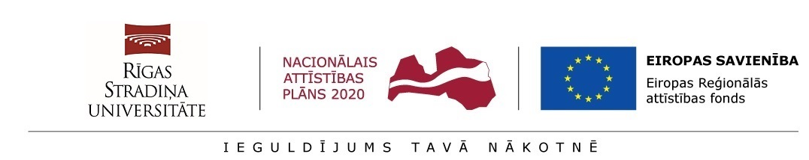

Annex 5
STATEMENT OF THE HEAD OF THE STRUCTURAL UNIT
__. _________.2020

________________________
(RSU structural unit)

_____________________
(Name, Surname of the Head of the Structural Unit))

I hereby confirm that I support the participation of the post-doctoral researcher _____________________________________________________________________________
in the research application project within the frame of Activity 1.1.1.2 “Post-doctoral Research Aid” of the Specific Aid Objective 1.1.1 “To increase the research and innovative capacity of scientific institutions of Latvia and the ability to attract external financing, investing in human resources and infrastructure” of the Operational Programme “Growth and Employment”.
Herewith I confirm that in the event of awarding aid for the implementation of the research application, the work place created in the Structural Unit for the implementation of the research application will be retained for the term of at least five years following completion of the implementation of the research application and future development of the research direction will be ensured.

_____________________________
(Signature of the Head of the Structural Unit)

