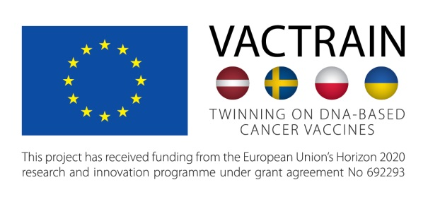

CANCER IMMUNOTHERAPY - GROUP TRAINING IN GRANT WRITING

Bellevue Park Hotel Riga, Slokas iela 1, Riga, Latvia
20 – 21 November 2018
AGENDA

Course takes max 4 participants, preference will be given to VACTRAIN trainees. Other applicants could be accepted if there are vacancies.
Registration for the course in the written form by e-mail to Ms Asja Lunga asja.lunga@rsu.lv
Deadline for application November 15, 2018.

Aim: To practice preparation of grant application in the field of cancer vaccine research.
Tasks: To improve a part of the application in lines with the reviewer critics, and considering changes in the frame of the call between previous and current calls.
Materials: For the type of application, and application forms, see 10th Transnational call EuroNanoMed III http://euronanomed.net/joint-calls/10th-joint-call-2019/
Call is likely to open on: 14th November 2018
Submission deadline for pre-proposals: 31st January 2019
Submission deadline of full proposals: 1st July 2019
Participating countries - Bulgaria, Canada (Quebec), Czech Republic, Estonia, France, Greece, Italy, Latvia, Lithuania, Norway, Poland, Romania, Slovakia, Spain, Taiwan. Turkey.

A week before the course (the latest November 14, 2018) each registered participant will be given a portfolio containing: (i) text of the call; (ii) draft of previously submitted application on the topic fitting the scope of the call; (iii) critical comments from reviewers; (iv) response of the applicants to the reviewers.
Training approach: The application will be divided into sections; each participant will be made responsible for refining one section. Each participant will get a personal task to refine a section of the proposal in lines with the comments of the reviewers, and a personal coach to instruct and guide during the revision process. Section revisions should be prepared as a home task, and discussed and revised during day 1. The original and revised sections (Word files) will be submitted by e-mail to the course leader and sent to be further assessed by an independent expert. Comments from the expert in written form will be received and discussed during group work on day 2. Training will be completed by assembly of sections into the renewed proposal. All participants will receive a certificate of attendance.

The TALLIN Conference Hall

DAY 1, NOVEMBER 20, 2018 (closed, for registered participants)
08.30-09.00 | Registration
09.00-09.30 | Javier Sanchez-Nieves Fernandez, University of Alcala, Madrid, Spain  Introductory lecture - GOLD NANOPARTICLES FOR NUCLEIC ACID DELIVERY
09.30-10.00 | Maria Issagouliantis, Rīga Stradiņš University, Riga, Latvia  Presentation of the research proposal NANOPARTICLE CARRIERS FOR TRIPLE ACTION THERAPEUTIC TUMOR VACCINES
10.00-10.30 | Coffee break
10.30-12.30 | Training in grant writing in trainee-coach pairs.
12.30-13.30 | Lunch
13.30 – 15.30 | Group discussion of progress. Submission of revised sections to course leader and independent expert for assessment.
15.30-17.30 | Coffee break and discussions of co-applicants (closed part)
The BERLIN Conference Hall

DAY 2, NOVEMBER 21, 2018 (for registered participants)
09.00 – 11.30 | Training in grant writing. Analysis of the critique by course leader and independent expert (parts 1-2)
11.30-12.30 | Lunch
12.30-14.30 | Training in grant writing. Analysis of the critique by course leader and independent expert (parts 3-4).
14.30-15.00 | Coffee break
15.00-16.00 | Re-assembly of proposal, course completion, award of certificates.
16.00-18.00 | Discussions of co-applicants (closed part)

